Miss Rogers’ Class Newsletter

December 12, 2017



Notes from B4-

Happy Holiday season! As you may have noticed, we decided to end rest time. The kids were not resting AT ALL and it was more of a disruption than a help ☺ We still have a quiet snack time. Thank you for encouraging your children to still be on their best behavior for these last two weeks of December. I know it is an exciting time for them but classroom rules and procedures have to stay in place.

**Important Reminders**

December 19- Cooking Class @ 2pm

December 21- Polar Express Day (the kids’ won’t know about this until next week, they will be allowed to wear their PJs ☺ )

December 22- Winter Break Begins- Happy Holidays

January 2- Return to School

January 12- End of Quarter 2 (Half way done with K!!)

January 15- No School

January 16- No School

* **Please complete reading folders every night**

**that**

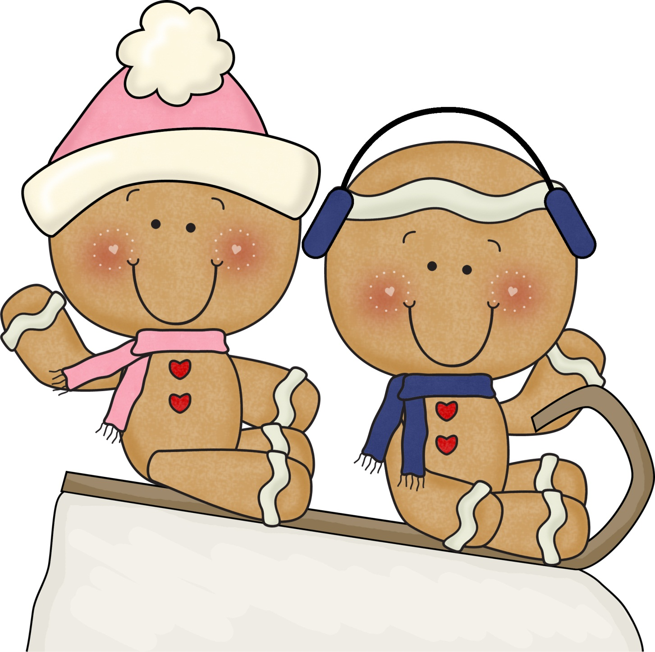



Sight Words

am on

at see

and said

are she

all the

but to

can that

for they

go was

he we

his with

have you

here **her**

I **what**

is **there**

in

it

like

of

This Week’s Curriculum:

**Theme**: Holiday Lights and Holidays Around the World

We will be learning about the following holidays this week: Kwanzaa, Hannukah, St. Lucia, and Las Posadas. Next week we will read “The Nutcracker” as well as look at Christmas around the world.

We have been working on retelling stories with the various Gingerbread Man tales, answering questions, and so much more.

Small group reading is going great. I have been making sure to review sight words with the kids as well as introduce a sight word poem at the beginning of our lesson. We are moving towards the students writing answers to some basic questions in response to their books after reading the text.

In math, we are working on basic addition. We have buddies who come from Carolina Friends School every Tuesday and Thursday and help out with our Math Centers!

